What is Environment Variable?

= environment variable mainly declare as **.env**

And it is a private file

How we can use environment variable?

=1st, create a .env file in the root directory

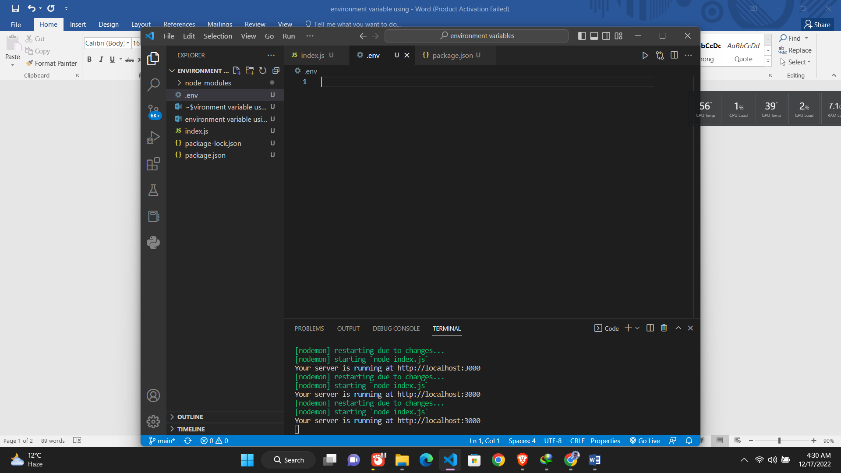

2nd , define environment variables using uppercase and underscore .

Example: PORT

DATABASE_URL

3rd ,assigning the value without double quotation or value

Example: PORT=3000

4th, you can make a comment using #

# this is a port

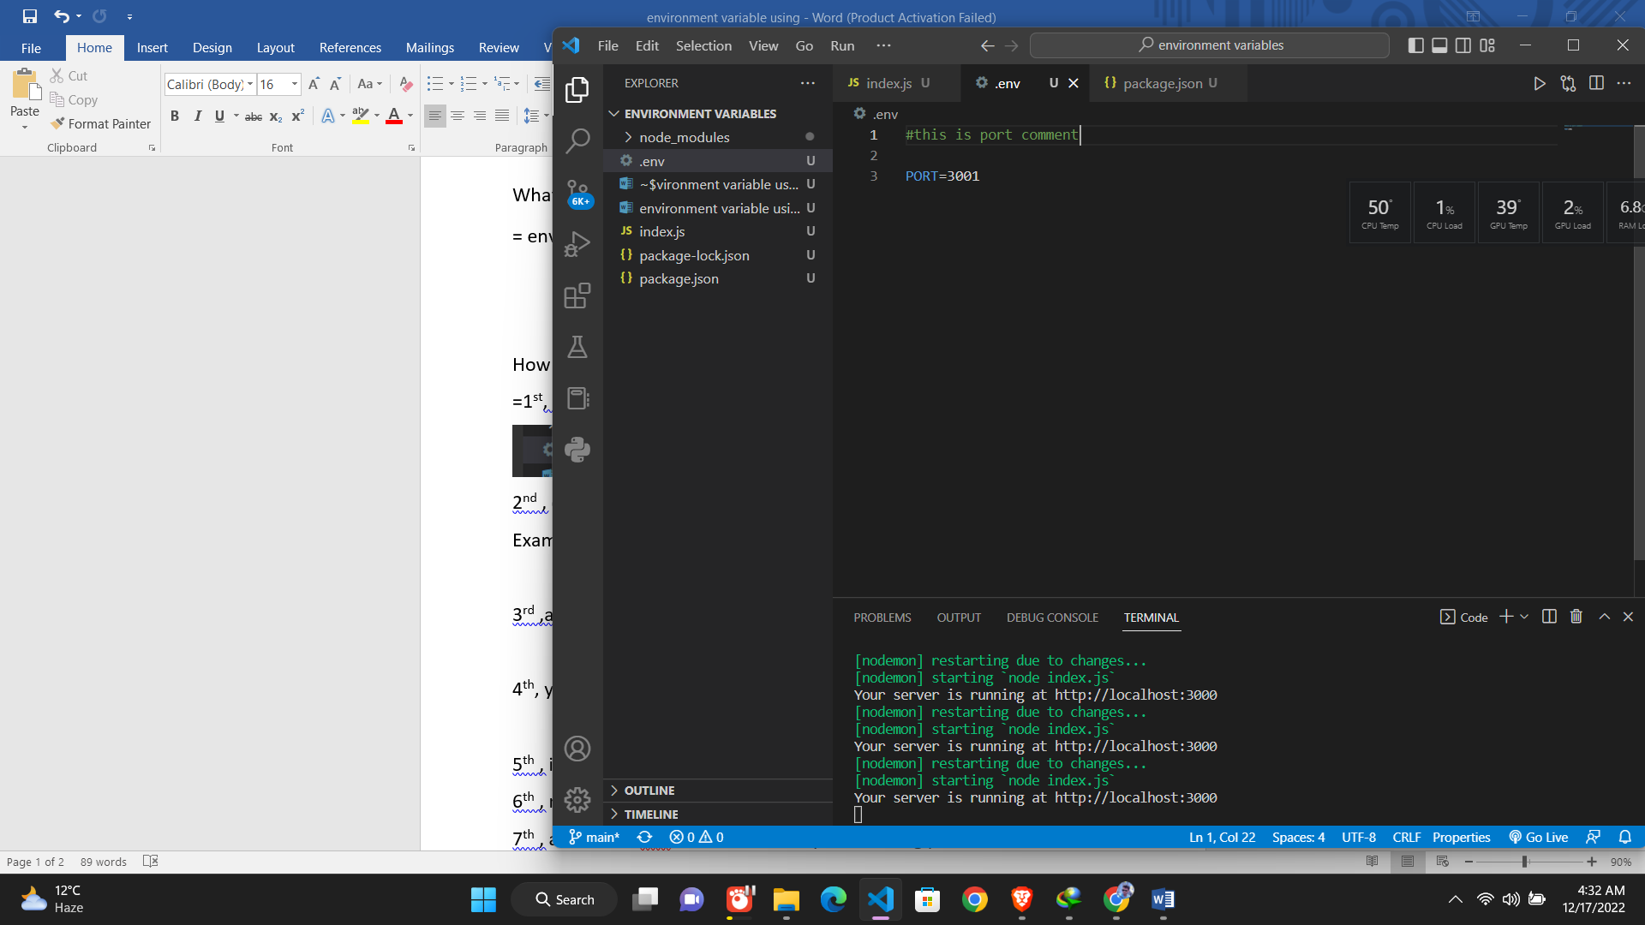

5th , install dotenv package 🡪 npm install dotenv

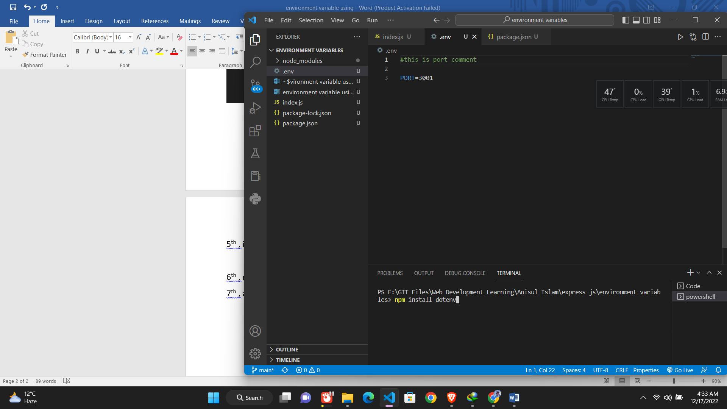

6th , require dotenv🡪 require(‘dotenv’).config();



7th , access the env variable from anywhere using process.env.name

Example: process.env.PORT

